Project Title
KAleep-Net: A Kolmogorov-Arnold Flash Attention Network for Sleep Stage Classification Using Single-Channel EEG with Explainability
1. What is this project about?
This project is about automatically identifying sleep stages of a person using only one EEG signal (single-channel EEG) by applying an advanced deep-learning model that is:
- Accurate
- Fast and lightweight
- Explainable (interpretable)
Normally, sleep staging is done manually by doctors using polysomnography, which includes many signals (EEG, EOG, EMG). This process is time-consuming, costly, and subjective.
2. What is the AIM of this project?
The main aim of KAleep-Net is:
To design an efficient and explainable deep-learning model that can accurately classify sleep stages using only a single EEG channel.
In simple words:
- Use minimum data (only one EEG signal)
- Still get high accuracy
- Make the model explain its decisions, so doctors can trust it
3. What are Sleep Stages?
Sleep is divided into 5 stages:
- Wake (W)
- N1 (Light sleep)
- N2 (Intermediate sleep)
- N3 (Deep sleep)
- REM (Dream sleep)
our model predicts which stage each 30-second EEG segment belongs to.
4. What is KAleep-Net? (Core Idea)
KAleep-Net is a hybrid deep-learning network made of three main concepts:
1️⃣ Kolmogorov-Arnold Representation
- Based on Kolmogorov-Arnold theorem
- Breaks complex EEG signals into simpler additive components
- Helps capture non-linear brain patterns
- Makes feature learning more meaningful
👉 Purpose: Better feature extraction from EEG
Plain-language summary
KAleep-Net is a neural network designed to classify sleep stages from a single EEG channel. It combines a Kolmogorov–Arnold inspired representation to capture nonlinear signal relationships with a Flash-Attention module to efficiently focus on long-range temporal dependencies. The model is lightweight, fast, and provides interpretable attention maps and attribution scores so clinicians can see which time–frequency patterns drive each stage prediction.
Abstract
Sleep staging from single-channel electroencephalography (EEG) is a clinically valuable but computationally challenging task, requiring models that capture nonlinear dynamics while remaining efficient and interpretable. We introduce KAleep-Net, a Kolmogorov–Arnold Flash Attention Network for automated sleep stage classification using only a single EEG channel. KAleep-Net first transforms raw EEG epochs using a Kolmogorov–Arnold decomposition to expose latent additive components that better separate stage-specific patterns. These representations are processed by a compact convolutional front end and a Flash-Attention–based temporal encoder that efficiently models long-range dependencies across multi-minute contexts. To support clinical interpretability, KAleep-Net outputs attention maps and per-sample attribution using integrated gradients and layer-wise relevance propagation, allowing visualization of the time–frequency features driving each prediction. We evaluate KAleep-Net on public sleep datasets and subject-wise cross-validation, reporting state-of-the-art or competitive epoch-level performance (accuracy, macro F1, and Cohen’s kappa) while using substantially fewer parameters and lower inference time than large transformer baselines. Ablation studies demonstrate the complementary benefits of the Kolmogorov–Arnold representation and Flash Attention. We also show example clinician-oriented visualizations that reveal physiologically plausible markers (e.g., K-complexes and spindles) highlighted by the model. KAleep-Net offers an efficient, explainable approach suitable for wearable or edge-deployable sleep monitoring systems.
Keywords
Sleep staging, EEG, single-channel, Kolmogorov–Arnold decomposition, Flash Attention, explainability, attention maps, integrated gradients

Core contributions (short bullets)
- Propose KAleep-Net: hybrid architecture combining Kolmogorov–Arnold decomposition and Flash-Attention for single-channel EEG sleep staging.
- Achieve competitive classification performance with a compact, low-latency model suitable for edge deployment.
- Provide multi-method explainability (attention visualization + attribution) with examples linking model focus to known sleep features.
- Thorough ablations showing the added value of K-A preprocessing and efficient attention.
Architecture overview (concise, implementable)
- Input & preprocessing
  - Single EEG channel, sampled (e.g., 100–256 Hz).
  - Segment into standard 30-s epochs (optionally include ±X seconds context).
  - Bandpass filter (0.3–35 Hz) + notch if necessary; z-score per session or per subject.
- Kolmogorov–Arnold (K-A) representation block
  - Compute additive decomposition / nonlinear component projection per epoch (practical implementations: series of 1D convolutions with nonlinearity that emulate additive basis or explicitly compute limited-order functional decomposition).
  - Output: multi-channel representation that highlights distinct nonlinear modes.
- Convolutional front end
  - 1D conv layers with small kernels (3–7), strided pooling to reduce temporal resolution, batchnorm, GELU.
- Temporal encoder: Flash-Attention module
  - Multi-head Flash Attention over reduced temporal tokens (efficient memory & time).
  - Use relative positional embeddings (sinusoidal or learned) to preserve temporal order.
- Classification head
  - Global pooling (or a CLS token) → dense layers → softmax over sleep stages (W, N1, N2, N3, REM or 5-class/4-class as needed).
- Explainability outputs
  - Per-head attention maps (projected back to time domain).
  - Integrated gradients / LRP attribution per epoch.
- Loss & training
  - Cross-entropy with class weighting or focal loss to handle class imbalance.
  - Optionally add a continuity loss encouraging stage smoothness across adjacent epochs.
Training & experimental suggestions
- Datasets: Sleep-EDF, MASS, ISRUC — run subject-wise cross validation (leave-one-subject-out or k-fold by subject).
- Metrics: epoch accuracy, macro F1, per-class F1, Cohen’s kappa, confusion matrix, sensitivity/specificity per class.
- Baselines: small CNN, Bi-LSTM, Transformer, DeepSleepNet, TinySleepNet.
- Ablation: remove K-A block, replace Flash Attention with standard MHSA, vary context window length, test without explainability losses.
- Hyperparams (starting points): lr=1e-3 with AdamW, batch 32, weight decay 1e-4, warmup 5% steps, train 50–100 epochs with early stopping.
- Data augmentation: time masking, channel dropout (simulate noise), small frequency jitter, epoch stacking (context).
Explainability & visualization techniques
- Attention maps: show per-head attention averaged across heads and overlay on EEG trace / spectrogram to highlight which time segments the model used.
- Integrated Gradients: compute per-sample attribution to show which samples/time-frequency bins most influenced the predicted class.
- Layer-Wise Relevance Propagation (LRP): complementary attribution method useful for non-linear networks.
- Time-frequency saliency: compute short-time Fourier / wavelet spectrogram and mask high-attribution time–freq bins to illustrate effect on prediction.
- Class prototypes: show representative epochs with strong attributions per class (helps clinician interpretation).
- Quantitative explainability: measure alignment between salient regions and annotated events (spindles, K-complexes) if available.
Figure/table suggestions
- Architecture diagram (blocks + shapes and parameter counts).
- Example attention & attribution overlays on raw EEG + spectrogram for each sleep stage.
- Confusion matrix & per-class F1 table vs baselines.
- Ablation plot showing performance drop when removing K-A or Flash Attention.
- Runtime/parameter count comparison (model size, inference ms on CPU/edge).
- t-SNE/UMAP of learned epoch embeddings colored by stage.
Limitations & potential pitfalls
- Single-channel models lose multi-lead spatial info; expect lower N1/N2/REM separation compared to multi-channel models.
- K-A decomposition implementation detail matters — could add computation overhead if implemented inefficiently.
- Explainability methods are approximations — validate against clinical annotations when possible.

Short checklist for writing the Methods section
- State EEG channel, sampling rate, epoch length, preprocessing steps (filter, normalization).
- Precisely describe K-A block: math + implementation (layers, order).
- Give Flash-Attention configuration: number of heads, key/query dims, token length, positional encoding.
- Training details: optimizer, lr schedule, batch size, epochs, early stopping, class weighting.
- Evaluation protocol: train/val/test splits, per-subject split logic, metrics.

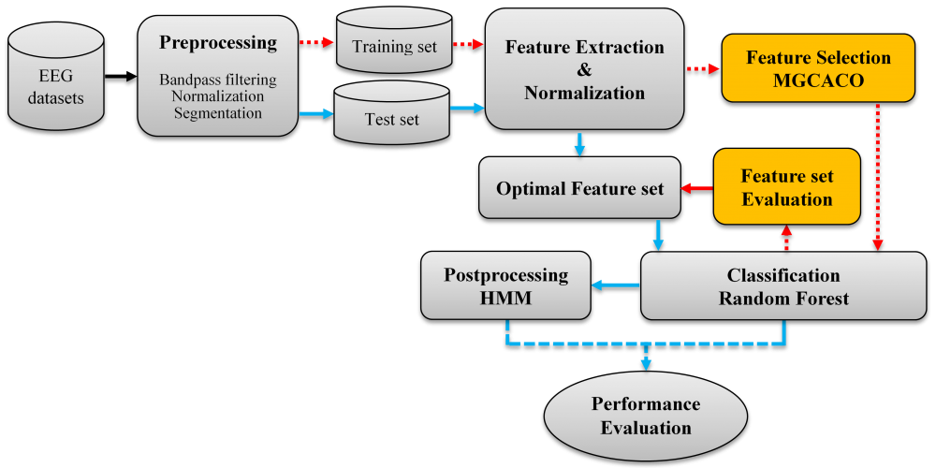

Overall Project Flow (Big Picture)
Your project follows this exact pipeline:
- Collect sleep EEG dataset
- Preprocess EEG signal
- Prepare training-ready dataset
- Build KAleep-Net model
- Train the model
- Evaluate performance
- Add explainability
- Report results

